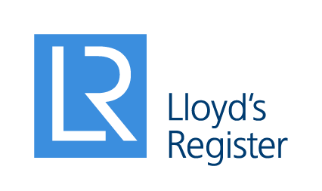 | Press release Immediate: 07 June 2017 LRE/OWE/03/17

Lloyd’s Register (LR) works with its clients to unlock the value in their data
At OWE 2017 in London, UK, 6 – 8 June, LR launches their Marine Analytics service with a methodology that will enable renewable companies to obtain value from operational data and connected assets.

The biggest challenge associated with data from multiple systems and connected assets, once security has been assured, is knowing how to turn the possibilities into actual commercial and operational value. It is now possible to amass more data more easily but with so much data available, extracting useful and actionable information and insights is a challenge.

LR is focused on working with low carbon energy, marine and offshore companies of all sizes to co-create leading bespoke solutions, enabling them to optimise efficiency in operations, asset performance and maintenance, reduce risk and improve safety while offering increased transparency to stakeholders.

The new marine analytics capability under the ‘Cyber Perform’ step of LR’s cyber and digital transformation spans from the deployment of the platform at vessel or fleet level to shore-side decision-making support.

The approach provides the right tools to embed data-driven insights within an organisation, complementing existing processes and procedures and providing the opportunity to centralise all data sources into one consolidated data view. LR’s world-class engineering knowledge is translated into advanced data analytics, underpinned by a pioneering and secure Connected Assets Big Data Platform powered by partner, QiO Technologies.

This platform is supported by LR’s industry-recognised software, such as real-time adaptive maintenance optimisation service and software (RTAMO), asset management optimisation service and software (Axxim) and loading and stability software (LR Seasafe), as well as by partnerships with leaders such as the cloud-based ship management software provider, Hanseaticsoft.

LR’s seven-step methodology moves the client through the following seamless journey:
• The power and potential of data – understanding, identifying and assessing the data a client has and what it can help them achieve.
• Defining a data strategy – a robust and practical plan for achieving the desired technical, operational and commercial outcomes.
• Enabling data analytics – providing a powerful, scalable platform to help consolidate operational data from assets with other data to give a fully integrated view, enabling powerful analytics to derive actionable insights.
• Providing value – quickly piloting solutions and demonstrating the benefits of data.
• Deployment – working with the client to scale from pilots to fully functional solutions across their business.
• Continuous improvement – a long-term partnership that keeps the solution relevant, reliable and secure.

Meet our experts at Offshore Wind Energy 2017 event in ExCel, London – UK, 6-8 June at Booth #S-K20 or go online at www.lr.org/lowcarbon for more information.
ENDS

Notes to editors
About Lloyd’s Register
Lloyd’s Register (LR) is a global engineering, technical and business services organisation wholly owned by the Lloyd’s Register Foundation, a UK charity dedicated to research and education in science and engineering. Founded in 1760 as a marine classification society, LR now operates across many energy industry sectors, with around 9,000 employees in the Group across 78 countries.
LR has a long-standing reputation for integrity, impartiality and technical excellence. Our compliance, risk and technical consultancy services give clients confidence that their assets and businesses are safe, sustainable and dependable. Through our global technology centres and research network, LR is at the forefront of understanding the application of new science and technology to future-proof our clients’ businesses.

For media enquiries contact
Jason Knights
Global Communications Manager
T +44 (0)20 7423 1741
M +44 (0)78 2728 2569
E jason.knights@lr.org

Lloyd's Register
71 Fenchurch Street, London EC3M 4BS, UK
T +44 (0)20 7709 9166
E news@lr.org

Lloyd’s Register and variants of it are trading names of Lloyd’s Register Group Limited, its subsidiaries and affiliates.

