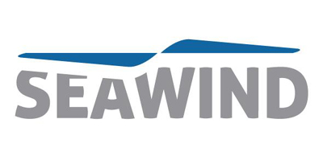

press call
6th June, 12.00pm – 12.30pm
Capital Suite 16, Level 3
Offshore Wind Energy
(Immediately Following Event Press Conference)

Seawind’s Revolutionary 2-Bladed Offshore Wind Energy Technology Receives Strategic Investment from Enzen Global

Seawind Systems and Enzen Global announce their partnership through which Enzen will contribute to funding and resourcing Seawind’s hurricane proof, low cost, 2-bladed Offshore Wind technology. This partnership will help Seawind accelerate commercialisation of their technology globally.

“This is a key milestone for our company as we move from proof of concept to commercialisation of our revolutionary 2-bladed offshore wind energy systems.” says Martin Jakubowski, Founder & CEO of Seawind. At Offshore Wind Energy he will reveal the details of the investment, outline the company’s strategic plans and present Seawind’s unique 2-bladed offshore wind system with a 3-D video.

Key Facts:
The Seawind system minimises costs and risks through:
- A 6.2 MW two-bladed upwind wind turbine
- Lower Capex and Opex than any other offshore wind solution
- Lowest life cycle cost for offshore wind farm systems, below € 0,08 ct/kWh installed offshore
- Hurricane and Typhoon (category 5) resistance through horizontal parking
- Easy installation globally avoiding specialized and costly supply chains, infrastructure and heavy crane vessels that conventional turbines require
- Integrated and complete Offshore Wind Energy System (wind turbine, support structure and low cost installation)
- Robust design with easy, low-cost maintenance that is done by a local construction company
- Wind Turbine Lifetime of 30+ years compared to 20 years for traditional three-bladed wind turbines

Seawind will demonstrate the cost, design and maintenance benefits of their 2-bladed energy system in the Holland Pavilion on Stand S-F22 from 6th to 8th June at Offshore Wind Energy.

For more information, please contact:
Sabine Raabe
Seawind Press Office
Biscuit PR
Email: sabine@biscuit-pr.co.uk
Mobile: +44-7966-417829

Press Call Location – 6th June 12.00-12.30pm:
Capital Suite 16 (2 doors from Main Press Conference)

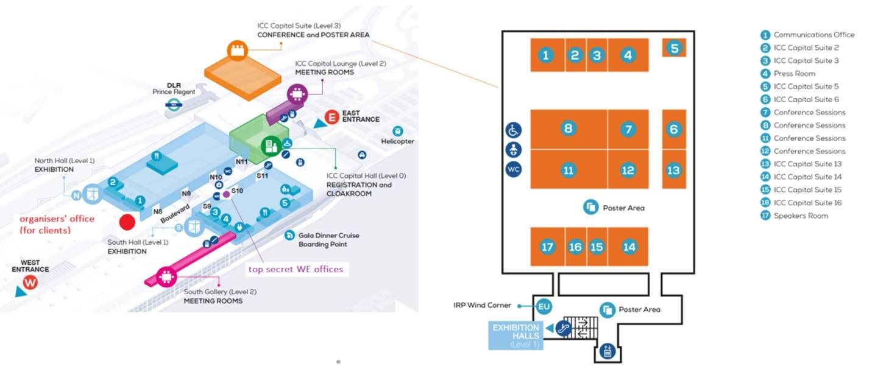
Seawind Technology was established with a vision to make offshore wind simple and cost-effective everywhere in the world. This vision is realised in a revolutionary, two-bladed offshore wind energy solution. Seawind distinguishes itself from traditional wind turbine manufacturers in that wind turbine engineering teams traditionally do not design both the support structures and installation methods at sea. Seawind Systems AS management has been working on offshore wind and renewable technologies for the past 20 years. The engineering branch of Seawind Systems AS, based in Genoa, is comprised of engineers specialising in the design of wind turbines. The Seawind technology was originally developed for grid scale energy production in the United States using the most sophisticated simulation software for helicopter rotors coming out of Hamilton Standard and NASA fundamental research results. This made it possible to adapt most efficiently to any wind conditions with the highest tolerance, reliability and safety under all weather conditions, including cyclones.
www.seawindtechnology.com

