Atlas Professionals to supply entire Marine Crew for the Bibby WaveMaster 1
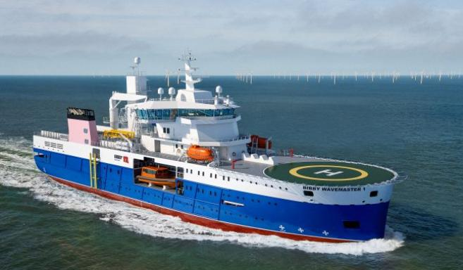
Over the years, Atlas Professionals has formed a strong partnership with the Bibby Line Group, collaborating on projects within the Energy, Marine and Renewables industries.

Exclusive supplier
Atlas Professionals is proud to be the exclusive supplier for marine crew to Bibby Marine Services new Service Operations Vessel (SOV) Bibby WaveMaster 1. The agreement will commence in July 2017 for two years.

A unique combination
Atlas’ teams based in Bristol, UK and Riga, Latvia will use their local expertise to source safe, reliable and competent UK and Latvian marine crew from Masters to Engineers and AB’s.
Bibby WaveMaster 1 will be deployed in the North Sea to support forthcoming offshore wind construction and O&M projects.
“What shone through from our very first meeting with Atlas Professionals, was not just their professionalism but how Atlas view the provision of personnel. They are clearly passionate about ensuring their employees are not only the best but managed in the best possible way. In the end it was this unique combination of professionalism, expertise and sector leading management systems that made us know we could trust Atlas with this critical human element of the Bibby WaveMaster 1.” –Stephen Bolton, Bibby Commercial Director.

Atlas Professionals
Since 1982, Atlas Professionals has been a major player in the provision of industry specialists to the Energy and Marine industries. With 18 offices and a presence in 14 countries, Atlas Professionals can turn complex personnel challenges into transparent and assured solutions wherever needed.

